**CHAPTER 1**

**INTRODUCTION**

In today’s digitalized world where everything happens on the fingertip with the fastest rate of delivery, it is even essential to move a step ahead in terms of one of the leading branch of making homemade chocolate and managing the records and details stored in the software by making a proper detailed structure of the various aspects of the shop and managing them through an app or so rather than doing it manually that may lead to unwanted error .

Through our project we are trying to improve this aspect of management. The natural homemade chocolate is majorly concerned by viewing all the details of the employee those are involved in the making or supplying of the products, updating their fields adding them and more. Production involves the supply, available stock display. There is a cart that displays the list of chocolates that being made and their per kilogram of price. There is another table for customer entry and the display of the current customer who are regularly.

**1.1 INTRODUCTION TO DBMS**

A database is an organized collection of data, generally stored and accessed electronically from a computer system. Where databases are more complex they are often developed using formal design and modeling techniques.

The database management system (DBMS) is the software that interacts with end users, applications, the database itself to capture and analyze the data and provides facilities to administer the database. The sum total of the database, the DBMS and the associated applications can be referred to as a "database system". Often the term "database" is also used to loosely refer to any of the DBMS, the database system or an application associated with the database.

Computer scientists may classify database-management systems according to the database models that they support. Relational databases became dominant in the 1980s. These model data as rows and columns in a series of tables, and the vast majority use SQL for writing and querying data. In the 2000s, non-relational databases became popular, referred to as NoSQL because they use different query languages.

**1.2 FUNCTIONS OF DBMS**

Existing DBMSs provide various functions that allow management of a database and its data which can be classified into four main functional groups:

Data definition: – Creation, modification and removal of definitions that define the organization of the data.

Update: – Insertion, modification, and deletion of the actual data.

Retrieval: – Providing information in a form directly usable or for further processing by other applications. The retrieved data may be made available in a form basically the same as it is stored in the database or in a new form obtained by altering or combining existing data from the database.

Administration: – Registering and monitoring users, enforcing data security, monitoring performance, maintaining data integrity, dealing with concurrency control, and recovering information that has been corrupted by some event such as an unexpected system failure.

**1.3 SQL DBMS**

IBM started working on a prototype system loosely based on Codd's concepts as System R in the early 1970s. The first version was ready in 1974/5, and work then started on multi-table systems in which the data could be split so that all of the data for a record (some of which is optional) did not have to be stored in a single large "chunk". Subsequent multi-user versions were tested by customers in 1978 and 1979, by which time a standardized query language – **SQL** [citation needed] had been added. Codd's ideas were establishing themselves as both workable and superior to CODASYL, pushing IBM to develop a true production version of System R, known as **SQL/DS**, and, later, Database 2 (DB2).

Larry Ellison's Oracle Database (or more simply, Oracle) started from a different chain, based on IBM's papers on System R. Though Oracle V1 implementations were completed in 1978, it wasn't until Oracle Version 2 when Ellison beat IBM to market in 1979.Stone baker went on to apply the lessons from INGRES to develop a new database, Postgres, which is now known as PostgreSQL. PostgreSQL is often used for global mission critical applications (the .org and .info domain name registries use it as their primary data store, as do many large companies and financial institutions).

In Sweden, Codd's paper was also read and Mimer SQL was developed from the mid-1970s at Uppsala University. In 1984, this project was consolidated into an independent enterprise. Another data model, the entity–relationship model, emerged in 1976 and gained popularity for database design as it emphasized a more familiar description than the earlier relational model. Later on, entity–relationship constructs were retrofitted as a data modeling construct for the relational model, and the difference between the two have become irrelevant.

**1.4 HTML**

**Hypertext Markup Language (HTML)** is the standard markup language for creating web pages and web applications. With Cascading Style Sheets (CSS) and JavaScript, it forms a triad of cornerstone technologies for the World Wide Web. Web browsers receive HTML documents from a web server or from local storage and render the documents into multimedia web pages. HTML describes the structure of a web page semantically and originally included cues for the appearance of the document.

HTML elements are the building blocks of HTML pages. With HTML constructs, images and other objects such as interactive forms may be embedded into the rendered page. HTML provides a means to create structured documents by denoting structural semantics for text such as headings, paragraphs, lists, links, quotes and other items. HTML elements are delineated by tags, written using angle brackets. Tags such as **<img />** and **<input />** directly introduce content into the page.

Other tags such as **<p>** surround and provide information about document text and may include other tags as sub-elements. Browsers do not display the HTML tags, but use them to interpret the content of the page.

**1.5 CSS**

**Cascading Style Sheets (CSS)** is a style sheet language used for describing the presentation of a document written in a markup language like HTML. CSS is a cornerstone technology of the World Wide Web, alongside HTML and JavaScript.

CSS is designed to enable the separation of presentation and content, including layout, colors, and fonts. This separation can improve content accessibility, provide more flexibility and control in the specification of presentation characteristics, enable multiple web pages to share formatting by specifying the relevant CSS in a separate .css file, and reduce complexity and repetition in the structural content.

Separation of formatting and content also makes it feasible to present the same markup page in different styles for different rendering methods, such as on-screen, in print, by voice (via speech-based browser or screen reader), and on Braille-based tactile devices. CSS also has rules for alternate formatting if the content is accessed on a mobile device.

The name cascading comes from the specified priority scheme to determine which style rule applies if more than one rule matches a particular element. This cascading priority scheme is predictable.

**1.6 PHP**

**PHP: Hypertext Preprocessor** (or simply PHP) is a server-side scripting language designed for Web development, and also used as a general-purpose programming language. It was originally created by Rasmus Lerdorf in 1994; the PHP reference implementation is now produced by The PHP Group. PHP originally stood for Personal Home Page, but it now stands for the recursive initialism PHP: Hypertext Preprocessor. PHP code may be embedded into HTML code, or it can be used in combination with various web template systems, web content management systems, and web frameworks. PHP code is usually processed by a PHP interpreter implemented as a module in the web server or as a Common Gateway Interface (CGI) executable.

The web server combines the results of the interpreted and executed PHP code, which may be any type of data, including images, with the generated web page. PHP code may also be executed with a command-line interface (CLI) and can be used to implement standalone graphical applications.

The standard PHP interpreter, powered by the Zend Engine, is free software released under the PHP License. PHP has been widely ported and can be deployed on most web servers on almost every operating system and platform, free of charge.

The PHP language evolved without a written formal specification or standard until 2014, with the original implementation acting as the de facto standard which other implementations aimed to follow. Since 2014 work has gone on to create a formal PHP specification.

**1.7 ARCHITECTURE OF DBMS**

**A Database Management system** is not always directly available for users and applications to access and store data in it. A Database Management system can be **centralised** (all the data stored at one location), **decentralised** (multiple copies of database at different locations) or **hierarchical**, depending upon its architecture.

**1-tier DBMS** architecture also exist, this is when the database is directly available to the user for using it to store data. Generally such a setup is used for local application development, where programmers communicate directly with the database for quick response.

Database Architecture is logically of two types:

1. 2-tier DBMS architecture
2. 3-tier DBMS architecture

**2-tier DBMS Architecture**

2-tier DBMS architecture includes an **Application layer** between the user and the DBMS, which is responsible to communicate the user's request to the database management system and then send the response from the DBMS to the user.

An application interface known as **ODBC**(Open Database Connectivity) provides an API that allow client side program to call the DBMS. Most DBMS vendors provide ODBC drivers for their DBMS.

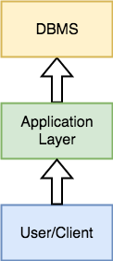

Such an architecture provides the DBMS extra security as it is not exposed to the End User directly. Also, security can be improved by adding security and authentication checks in the Application layer too.

**3-tier DBMS Architecture**

3-tier DBMS architecture is the most coA 3-tier architecture is a type of software architecture which is composed of three “tiers” or “layers” of logical computing.

They are often used in applications as a specific type of client-server system. 3-tier architectures provide many benefits for production and development environments by modularizing the user interface, business logic, and data storage layers.

Doing so gives greater flexibility to development teams by allowing them to update a specific part of an application independently of the other parts.

This added flexibility can improve overall time-to-market and decrease development cycle times by giving development teams the ability to replace or upgrade independent tiers without affecting the other parts of the system. Commonly used architecture for web applications.

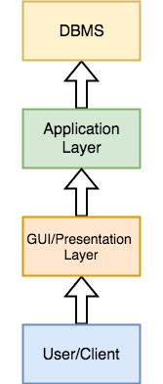

It is an extension of the 2-tier architecture. In the 2-tier architecture, we have an application layer which can be accessed programatically to perform various operations on the DBMS. The application generally understands the Database Access Language and processes end users requests to the DBMS.

In 3-tier architecture, an additional Presentation or GUI Layer is added, which provides a graphical user interface for the End user to interact with the DBMS.

For the end user, the GUI layer is the Database System, and the end user has no idea about the application layer and the DBMS system.

If you have used **MySQL**, then you must have seen **PHPMyAdmin**, it is the best example of a 3-tier DBMS architecture.

**CHAPTER 2**

**SYSTEM ANALYSIS**

**2.1 LITERATURE SURVEY**

Is there a need for “healthy” chocolate?

Chocolate has especially properties that help to protect human body against cardiovascular diseases; it increases HDL cholesterol and decrease blood pressure. Chocolate consumption also helps to reduce stress, elevates mood and reduces tiredness.

Objectives: Analyze the relevance of a healthy chocolate based on consumer´s needs, expectations and perceptions.

Methods: The present project studies three areas related to chocolate: Chocolate and its relation to health, Chocolate sensory characteristics and acceptance, and attitudes towards Chocolate. A systematically literature review has been part of this study together with consumer research based on a questionnaire. The questionnaire includes a sensory test of five different sugar-content chocolates. The questionnaire has been applied in Belgium and in Denmark among university students. A sample size of 215 participants has been part of this study.

Results: There is a significant difference when comparing the consideration of dark chocolate as part of a healthy lifestyle among countries. 46.7% of the participants in Belgium consider dark chocolate part of a healthy lifestyle while in Denmark 68.2% does. Danes prefer to eat dark chocolate rather than milk chocolate, and Belgians prefer milk rather than dark chocolate. The liking of the five chocolate samples varies significantly among countries but not by gender. And as it has been found in the literature, there is a contrast when comparing the attitudes towards chocolate among gender. There is a tendency of women craving or feeling guilty after eating chocolate.

Conclusion: Based on this project it can be concluded that there is a need for “healthy” chocolate. The literature supports the health properties that chocolate consumption has and the consumers are willing to purchase a chocolate product with sugar and calories reduced.

Keywords: Chocolate, health, sensory characteristics, attitudes State of the art

In relation to health, it has been found that chocolate consumption even in large quantities improves endothelial, platelet function and reduces blood pressure. This effects might because by the flavanols present in the cocoa ( Buijsse, Weikert, Drogan, Bergmann, & Boeing,2010 ).

Sarriá et al. (2014) states that the content of polyphenols in chocolate, especially flavanols have a potential to improve health, but the effects that chocolate might have like acting as antioxidant , anti-inflammatory can vary from person to person and it always depend on the person´s health and diet.

Chocolate´s studies are really close related with health but it is also related to attitudes ,emotions, feelings and beliefs: Polyphenols1 provide astringency and bitterness to chocolate and this does not fulfill consumer expectations (Harwood, Ziegler, & Hayes, 2013) but there is a health interest in preserving polyphenols content in chocolates. According to Lenfant et al.(2013) shape has an influence on chocolates´ characteristics perception like cocoa, caramel ,aftertaste and texture. Chocolate shapes are also usually associated to a certain type of chocolate and melting speed. Milk chocolate is usually associated to round shapes while dark chocolate is associated with angular shapes (Ngo, Reeva, & Spence, 2011).

In connection to attitudes towards chocolate: In one of the studies it has been reported that one of the most important reasons for craving chocolate is liking or satisfaction (Osman &Sobal, 2006) but, there are also some cultural, psychosocial and physiological factors that might lead to this (Hormes, Orloff, & Timko, 2014). Macht & Mueller (2007) states that a small amount of chocolate has an influence in improving negative mood just after its consumption and it might be due the chocolate´s palatability.

**2.2 PROPOSED SYSTEM**

**2.2.1 SCOPE OF THE PROJECT:** Like any other business, you will have to find out your comfort zone in the world of chocolates. Though this may sound quite uncanny because chocolate itself has been your comfort zone; but think of all the items that can be made from chocolates. The list is really endless with chocolate cookies to brownies to fudge to candies to caramelized chocolate bars to nutty rolls to all other tempting items.

For this, you will also have to study the present scenario of the chocolate market to know which products are in demand and which ones are lacking in supply. You may follow the trend or be confident enough to launch your own homemade chocolate making business that has been crafted with your wholehearted love and an exotic recipe and sculpt out an altogether new variant of chocolates that would take the world by storm. Giving a name to your business and setting it up. Once you have found Give it a name that people would immediately fall for and instigated to give it a try. The name if your chocolate brand should reflect your love and passion along with the goodness of chocolates.

Other than the name, the packaging of your chocolates should also be bright and beautiful with colorful shades and dazzling shimmer. It is absolutely advisable to add your personable ideas into the packaging. For instance, you can add tales about how are chocolates derived from cocoa beans, how people came to know about cocoa beans and such other unique stuff. If researching about all these items appears too hectic for you then you may add your personal love tale about chocolates, if you have any fond memories of sharing chocolates with someone special, or if your children have helped you develop the recipe or if it is a traditional formula of your family. By including something exclusively personal, you will be able to establish a bond of empathy and compassion with your consumers which would be really worth it.

**Choosing the target group of consumers:-** Though chocolates are loved by all, in business, you must be aware of a particular group of consumers that you are willing to serve. You must have grown up consuming chocolates from various brands, both national and international. Some are high-priced while others are relatively low.

There are quite a good number of big players in the market and their numbers and effectiveness are continuously on the rise. But have you ever noticed the fact that most of these chocolates are charged at a rate in which parents from the lower strata of the society are not able to buy them for their kids. Such children also have their birthdays and they too dream of distributing chocolates amongst their classmates on their special days, but no companies have paid heed to their emotions and desires.

**2.2.2 AIM OF THE PROJECT**: The considered problem of homemade chocolate business is that there is no proper data maintenance and there are problems of human error due to normal data entry. There is another aspect that is causing problem to the business is the wastage of the resources and produce which may be hindering the produce and profits. We are providing solution to the above mentioned problem as an organized and systematic solution is essential for every organization and business in today’s world.

**CHAPTER 3**

**REQUIREMENTS SPECIFICATION**

**3.1 SYSTEM REQUIREMENTS**

**3.1.1 Hardware Requirements**

* **Processor:** Intel Core2 Quad @ 2.4Ghz on Windows® Vista 64-Bit / Windows® 7 64-Bit / Windows® 8 64-Bit / Windows® 8.1 64-Bit.
* **RAM:** 2GB of RAM
* **Memory:** 256GB Hard drive
* **Keyboard:** MS compatible keyboard
* **Mouse:** MS compatible mouse

**3.1.2 Software Requirements**

* **Operating system:** Windows® Vista 64-Bit / Windows® 7 64-Bit / Windows® 8 64-Bit / Windows® 8.1 64-Bit.
* **Front end:** HTML,CSS
* **Back end:** My SQL database
* **Software:** WAMP
* **Connection:** php

**3.2 DEVELOPMENT ENVIRONMENT**

**HTML**: HTML elements are the building blocks of HTML pages. With HTML constructs, images and other objects such as interactive forms may be embedded into the rendered page. HTML provides a means to create structured documents by denoting structural semantics for text such as headings, paragraphs, lists, links, quotes and other items

**CSS:** CSS is designed to enable the separation of presentation and content, including layout, colors, and fonts. This separation can improve content accessibility, provide more flexibility and control in the specification of presentation characteristics, enable multiple web pages to share formatting by specifying the relevant CSS in a separate .css file, and reduce complexity and repetition in the structural content.

**PHP**: Hypertext Preprocessor (or simply PHP) is a server-side scripting language designed for Web development, and also used as a general-purpose programming language. Hypertext Preprocessor. PHP code may be embedded into HTML code, or it can be used in combination with various web template systems, web content management systems, and web frameworks. PHP code is usually processed by a PHP interpreter implemented as a module in the web server or as a Common Gateway Interface (CGI) executable.

The web server combines the results of the interpreted and executed PHP code, which may be any type of data, including images, with the generated web page.

**SQL:** SQL is a domain specific language used in programming and designed for managing data held in a relational database management system or for stream processing in a relational data stream management system (RDSMS). It is particularly useful in handling structured data where there are relations between different entities/variables of the data .SQL offers two main advantages over older read/write APIS like ISM or VSAM.

**CHAPTER 4**

**SYSTEM DESIGN**

**4.1 ER-DIAGRAM**

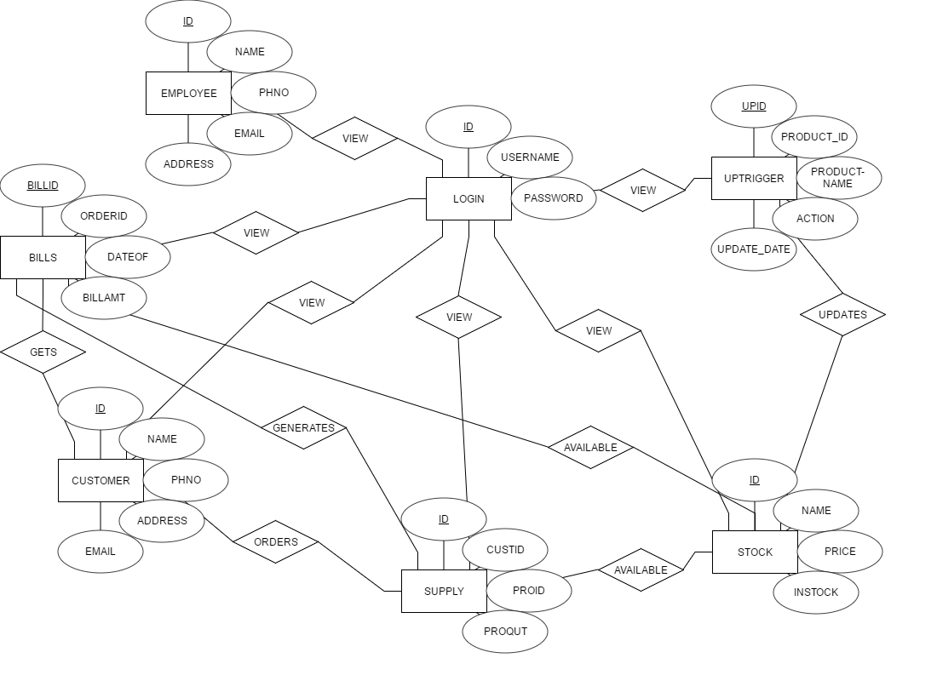

**Fig: Entity Relationship Diagram**

**4.2 SCHEMA DIAGRAM**

LOGIN

EMPLOYEE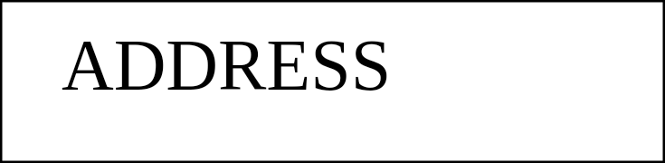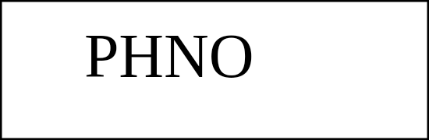

CUSTOMER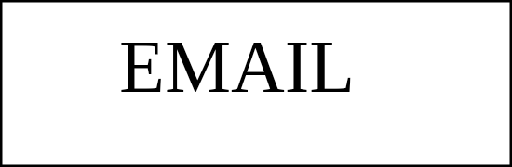



STOCK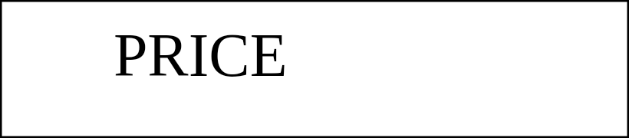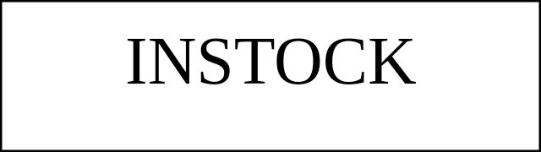



SUPPLY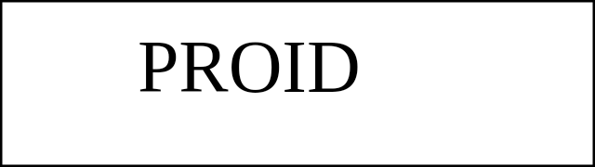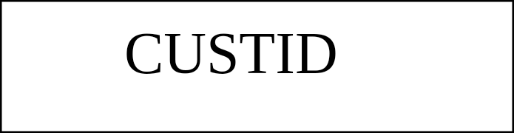



BILLS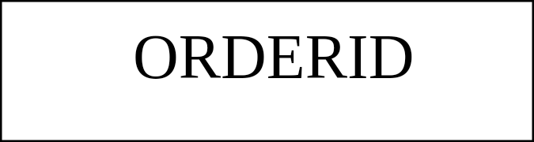

UPTRIGGER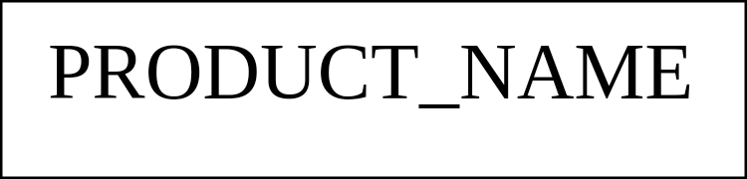

**Fig: Relational Schema**

**CHAPTER 5**

**SYSTEM IMPLEMENTATIONS**

**5.1 TABLES**

**5.1.1 LOGIN**

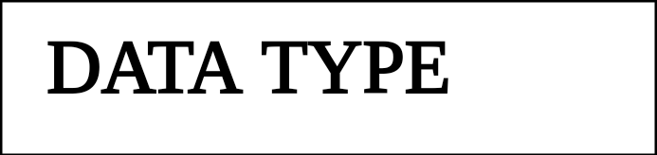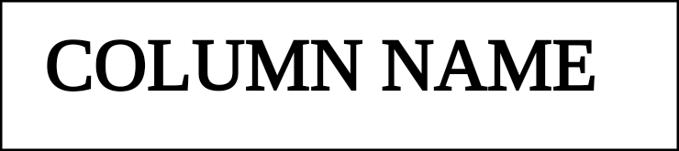



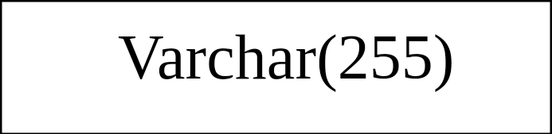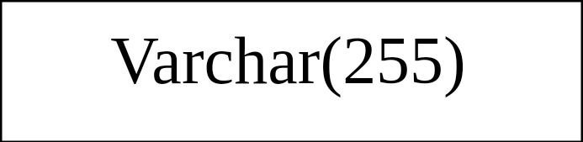

**5.1.2 EMPLOYEE**

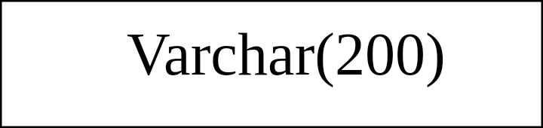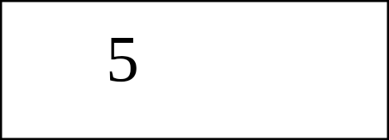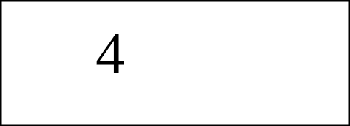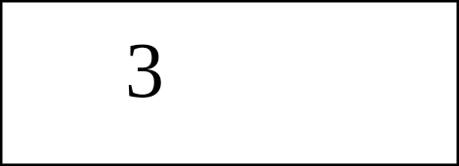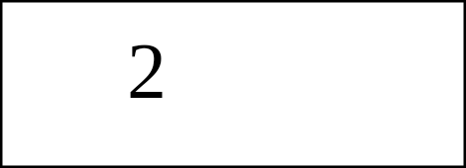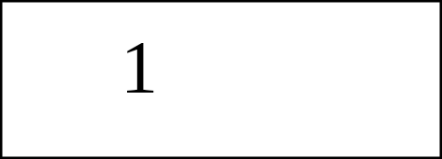

**5.1.3 STOCK**

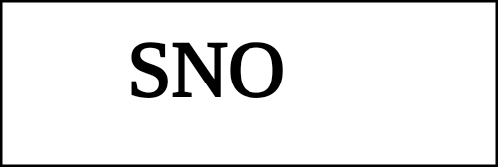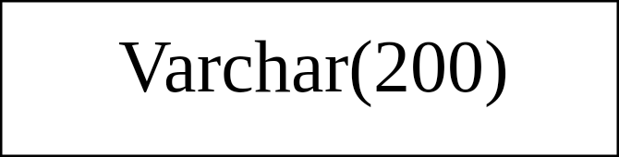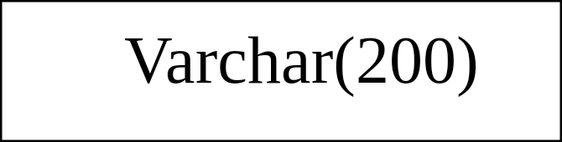

**5.1.4 CUSTOMER**

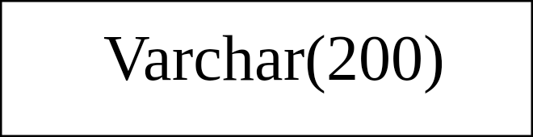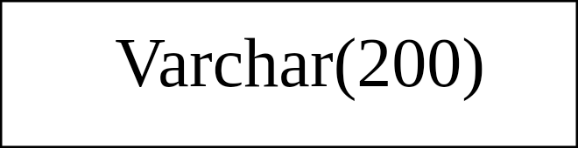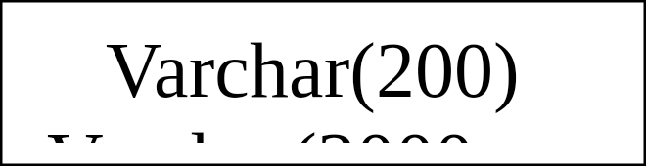

**5.1.5 SUPPLY**

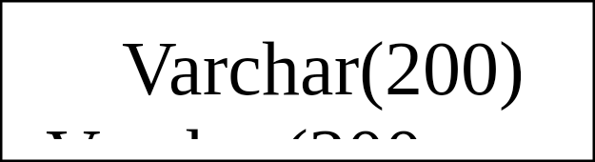

**5.1.6 BILLS**

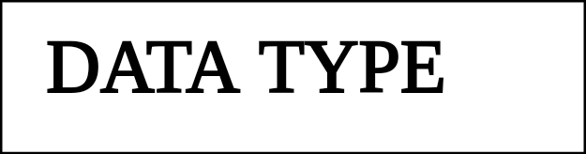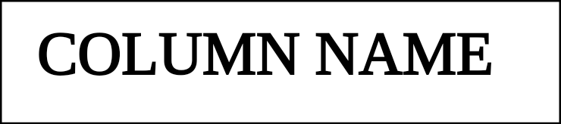



**5.1.7 UPTRIGGER**

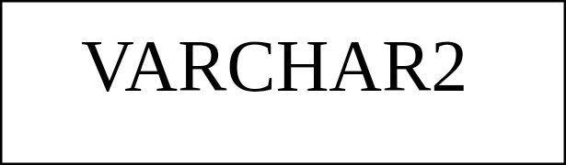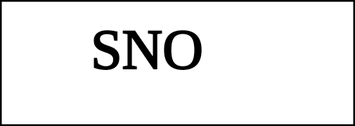

**5.2 QUERIES**

**5.2.1 LOGIN:** CREATE TABLE LOGIN(

ID INTEGER(225) PRIMARY KEY,

USERNAME VRCHAR(220),

**5.2 QUERIES**

**5.2.1 LOGIN:** CREATE TABLE LOGIN(

ID INTEGER(225) PRIMARY KEY,

USERNAME VRCHAR(220),

PASSWORD VARCHAR(220));

**5.2.2 EMPLOYEE:** CREATE EMPLOYEE(

ID INTEGER(200) PRIMARY KEY,

NAME VARCHAR(200),

PHNO INTEGER(200),

EMAIL VARCHAR(200)

ADDRESS VARCHAR(200));

**5.2.3 STOCK:** CREATE TABLE STOCK(

ID INTEGER(200) PRIMARY KEY,

NAME VARCHAR(200),

PRICE INTEGER(200),

INSTOCK VARCHAR(200));

**5.2.4 CUSTOMER:** CREATE TABLE CUSTOMER(

ID INTEGER(220) PRIMARY KEY,

NAME VARCHAR(200),

PHNO INTEGER(200),

EMAIL VARCHAR(200),

ADDRESS VARCHAR(200));

**5.2.5 SUPPLY:** CREATE TABLE SUPPLY(

ID INTEGER(200) PRIMARY KEY,

CUSTID INTEGER(200),

PROID INTEGER(200),

PROQUT VARCHAR(200));

**5.2.6 BILLS:** CREATE TABLE BILLS(

ORDERID INTEGER(200),

DATEOF DATE,

BILLAMT INTEGER(200));

**5.2.7 UPTRIGGER:** CREATE TABLE UPTRIGGER(

UPID INTEGER,

PRODUCT_ID INTEGER,

PRODUCT_NAME VARCHAR(200),

ACTION VARCHAR(200),

UPDATE_ DATETIME);

**5.3 PROCEDURES**

BEGIN

SELECT BILLID, ORDERID, BILLAMT, CUSTID, PROID, PROQUT, NAME, PRICE

FROM BILLS

INNER JOIN SUPPLY

ON BILLS.ORDERID=SUPPLY.ID

INNER JOIN STOCK

ON SUPPLY.PROID=STOCK.ID

END

**5.4 TRIGGERS**

BEGIN

INSERT INTO UPTRIGGER VALUES(NULL,NEW.ID,NEW.NAME,”UPDATED”,

NOW());

END

**CHAPTER 6**

**SNAPSHOTS**

The following snapshot show the login page of the admin by logging in to which an admin can view the stock, supply, employee, customer, bills and updates stock.

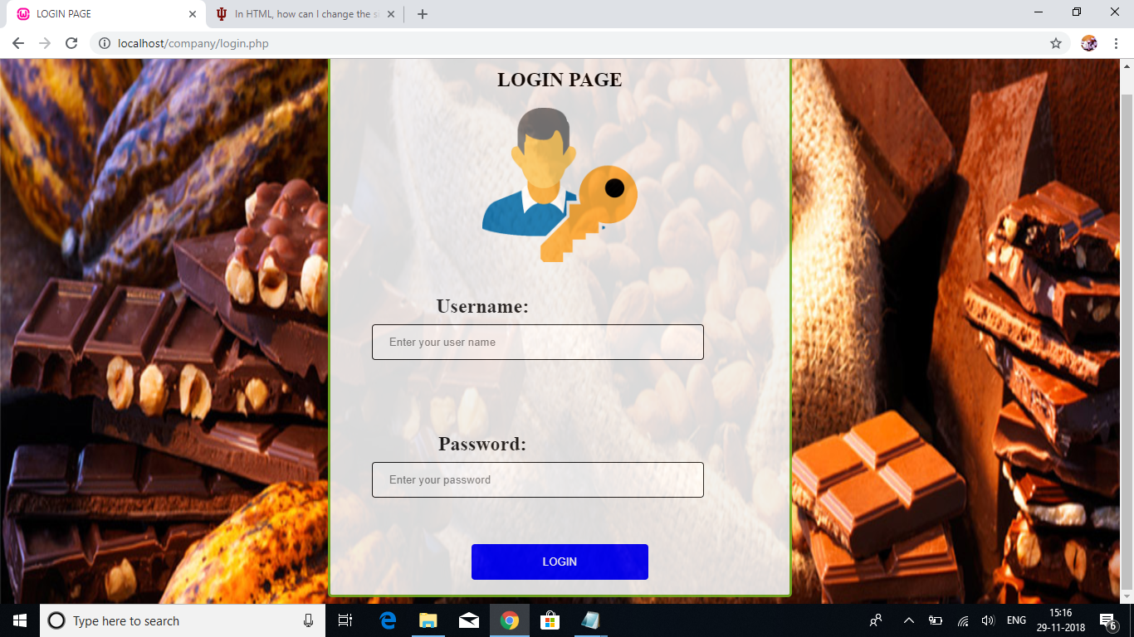

Once the admin is logged in he can view about us for our small homemade business.

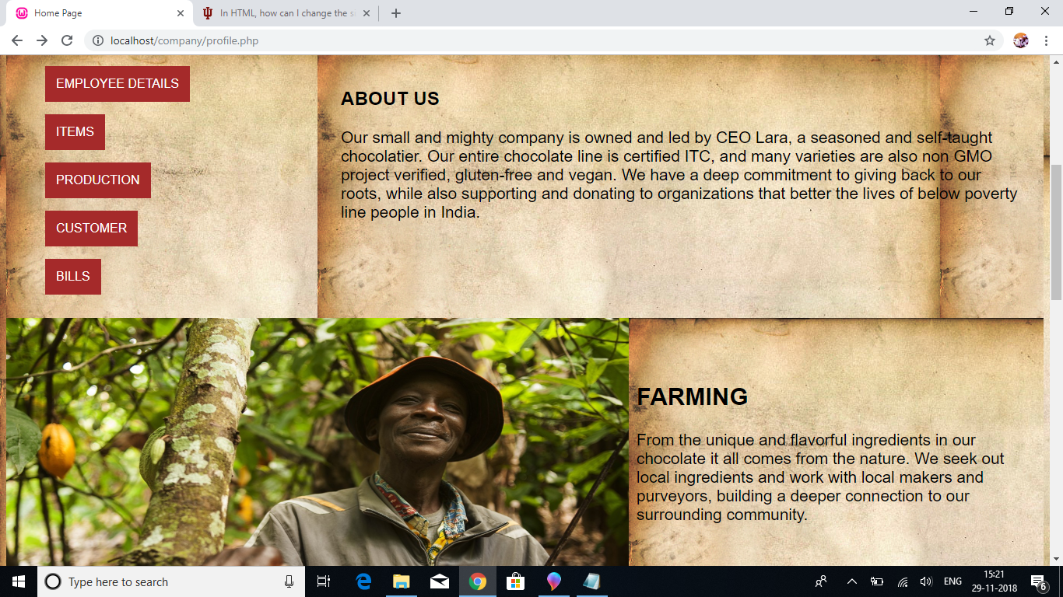

A new employee details can be entered and henceforth information about the employee details can be displayed.

.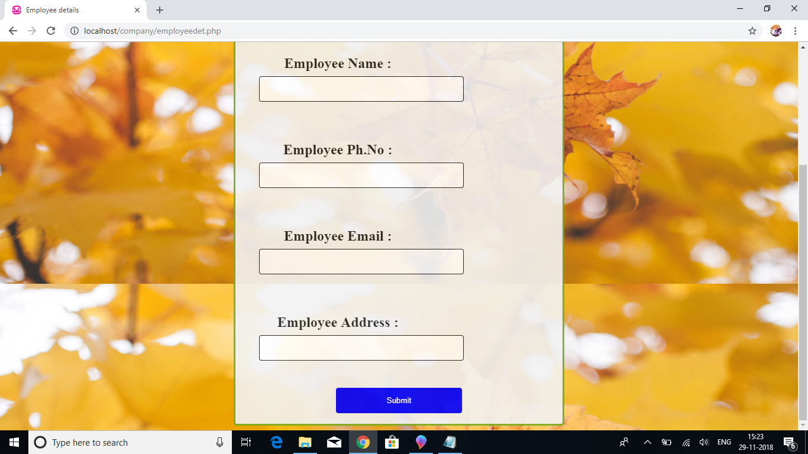

The details so entered is stored in backend and is retrieved on the frontend as employee details.

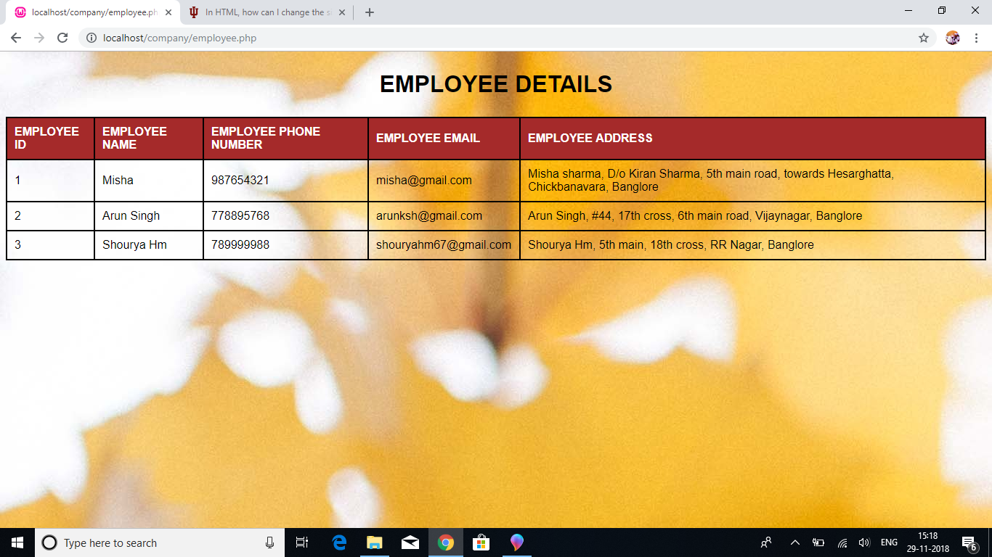

The details for the customer can be entered by the admin through the customer entry similar to that of employees.

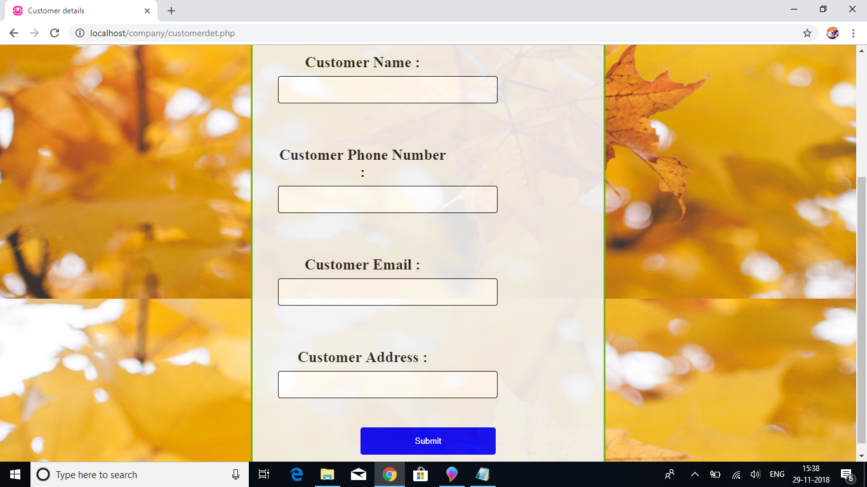

Once the entry is made the data is stored in the backend and is retrieved on the frontend as customer detail display.

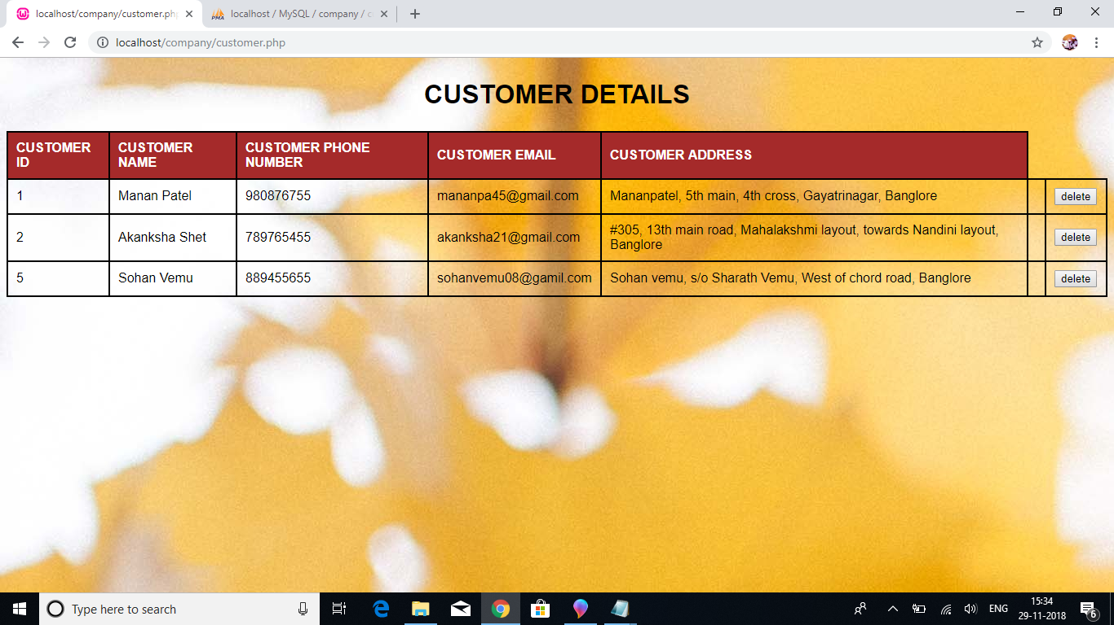

The product that is being made and sold by our small homemade business is displayed which can be seen by the admin as product details.

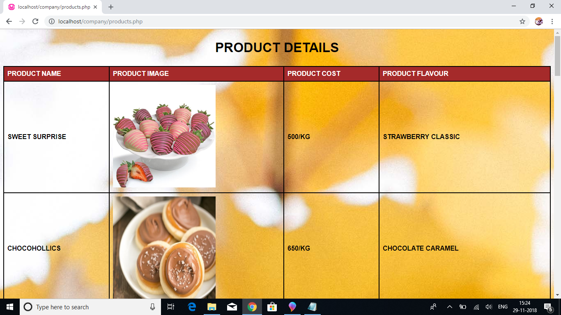

The ingredients that is used up in making the above listed product is displayed as the ingredients details.

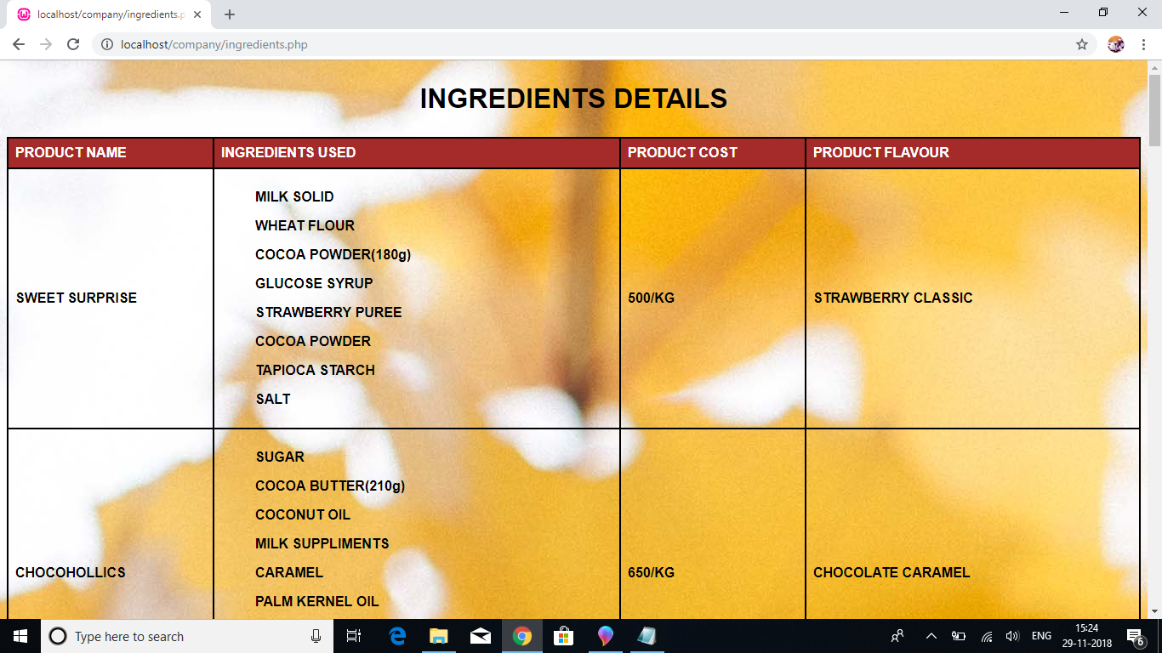

The next is to enter the available stock as in stock entry .Here the product name, the price of the product as well as the available in stock quantity per kg is entered.

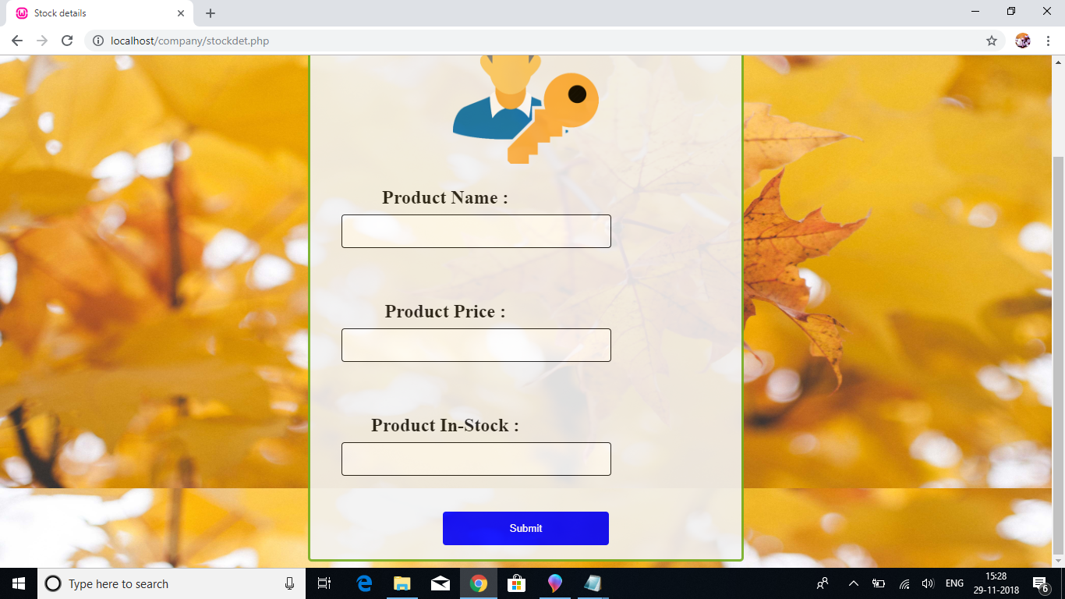

Stock details so entered are displayed and it comes with an update command wherein any of the stock entered values can be updated.

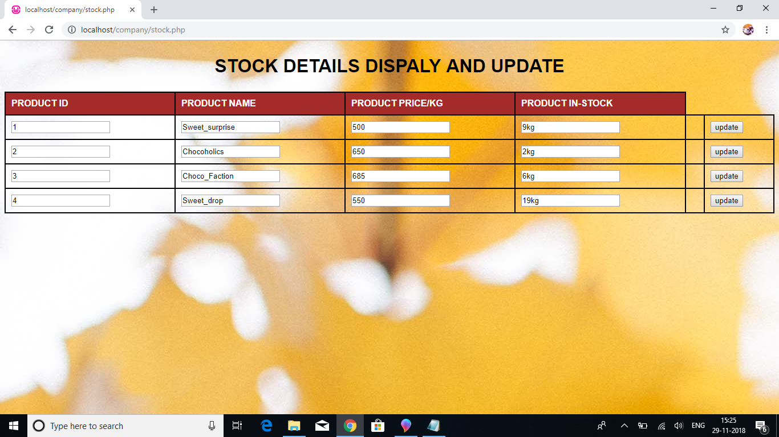

The order or the supply details can be entered and order is put up which is referenced to customer id and the id of the product along with the quantity.

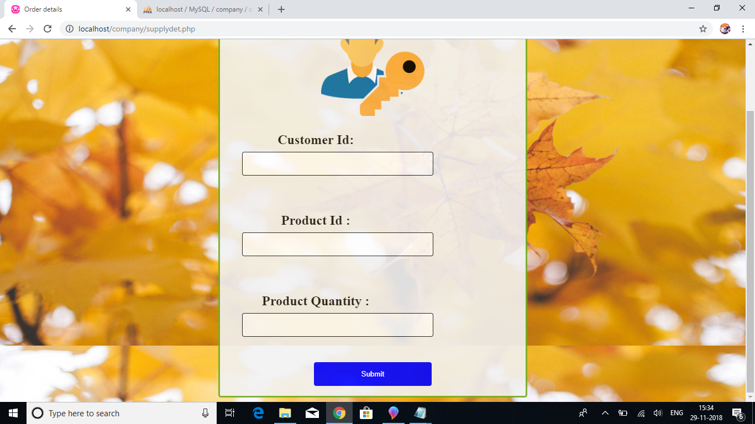

The order details are displayed where customer id ,product id product quantity ,product pricing name of the customer to whom the product has to be delivered, customer’s address and his contact number is displayed .Here join operation had been used on the backend to join customer with stock.

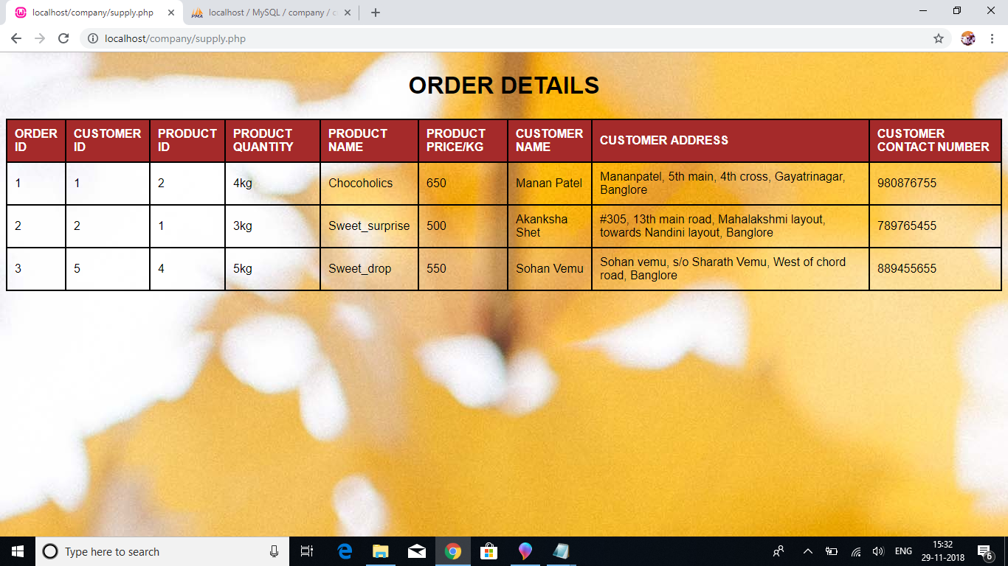

The next comes is the billing wherein bill data such as order number, date of the order of the product and the amount of the bill to be paid is entered.

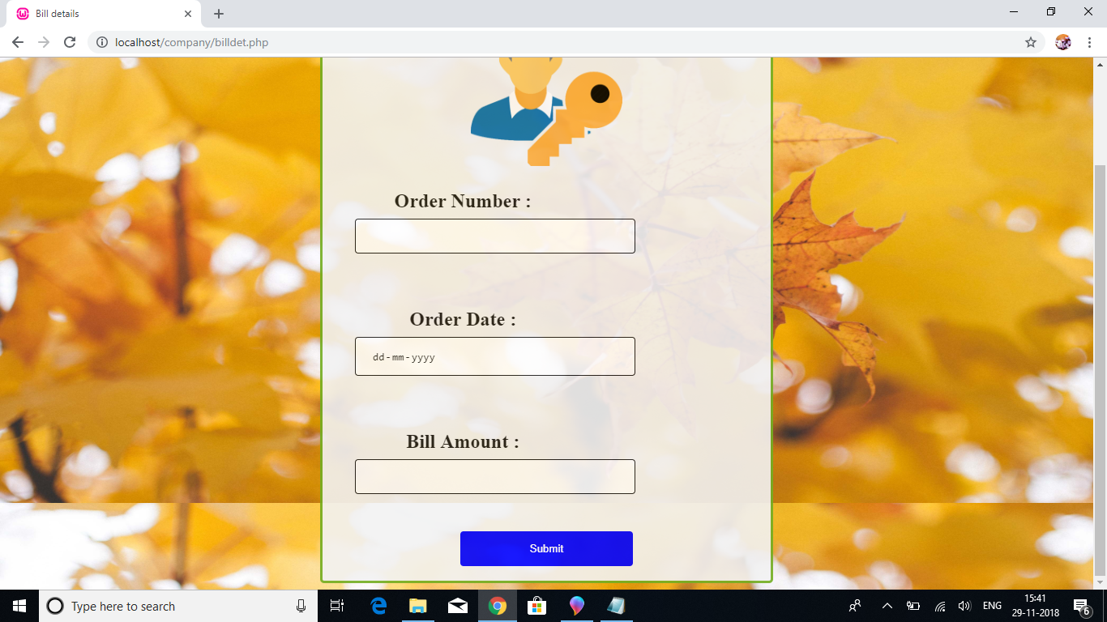

The bill details are displayed in the figure below where the entire detail about the billing of a product is done with reference to the customer and also the date of order and the bill amount is mentioned this bill table makes use of the stored procedure.

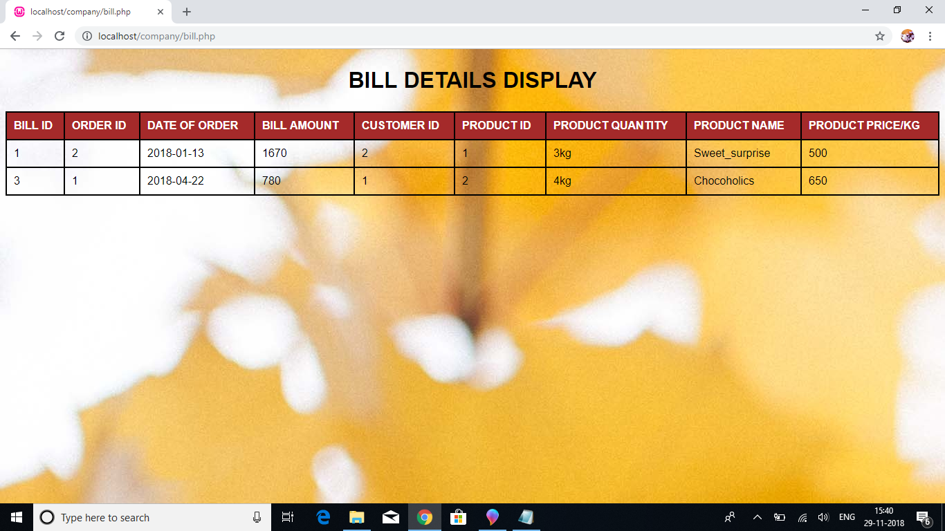

The given figure below shows the update history of the product that is being updated .It makes us of the triggers. Along with the action performed that is updation it also displays the date and time of the product updation.

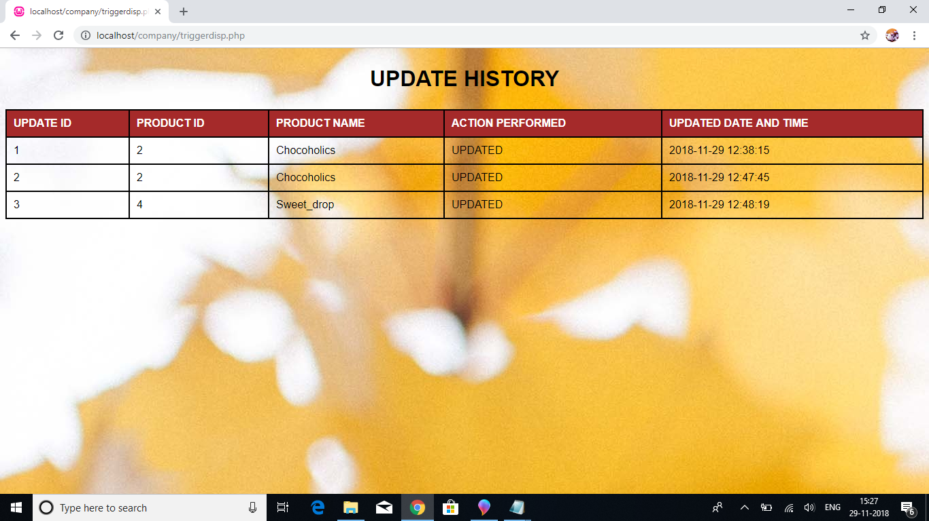

**CHAPTER 7**

**CONCLUSION AND FUTURE ENHANCEMENT**

**CONCLUSION**

For nearly every business sustainability is a key objective. Creating a sustainable homemade chocolate business benefits all of the business’s distributors from the owner to the employee.

The homemade chocolate business is working with the relevant partners to create a sustainable future. By cooperating in this way it is possible to improve the sustainability of the business better working conditions on farms, better quality cocoa, fair prices for all contributors, superior and more varied chocolate more satisfied customers.

**FUTURE ENHANCEMENT**

In a nutshell, it can be summarized that the future scope of the project circles around maintaining information regarding:

* A printer can be added in the future for printing the bills.
* More advance software can be used for homemade chocolate business including more facilities.
* The platform can be hosted on the online servers to make it accessible worldwide.
* Integrate multiple load balancers to distribute the loads of the system.
* Implement backup mechanism for taking backup of database on regular basis on different servers.

**REFERENCES**

<https://www.w3schools.com/html/>

For leaning html

<https://www.codecademy.com/learn/learn-css>

For learning css

<https://www.learn-php.org/>

For learning php

<https://www.codecademy.com/learn/learn-sql>

For learning sql

<https://www.cloudways.com/blog/connect-mysql-with-php/>

For connection between sql and php

**Book References**

1. Fundamentals of Database Systems, RamezElmasri and Shamkant B. Navathe, 7th Edition,

2017, Pearson

2. Herbert Schildt, Java The Complete Reference, 7th Edition, Tata McGraw Hill, 2007